|  |  |  |  |  |  |
| --- | --- | --- | --- | --- | --- |
| **Module No:** | 8 | **IU No:** | 5 | **Exercise No.** | 5 |

Learner Name : Agung Yuda Pratama  
Cohort : BDSE-0922-076 / STTB

|  |  |
| --- | --- |
| **Lab Assessment Statement** | **Assignment 4 – Implement webhook integration with external App**  **Referring to Assignment-1's Project Scenario,**  The scope of this assignment is to implement webhook Integration for notification using Slack for ‘XYZ Cars Pte Ltd’.  These are the steps provided to build an API.   1. Set up slack for Integration 2. Creating an App for webhook integration 3. Enabling Webhook in App 4. Implement webhook Integration in XYZ portal which is already developed. 5. Testing using Postman 6. Use the API in React Application.   **Provide the source code of developed application.**  **Provide screen capture of final result pages for API testing.** |
| **Technical Environment** | - Spring Boot, Slack for Integration, POSTMAN, React JS |
| **Guidelines** | - |
| **Duration** | 120 mins |

1. **Set up Slack for Integration**
   1. **Open slack.com to register your account if you don’t have one, you can register with a Google account also.**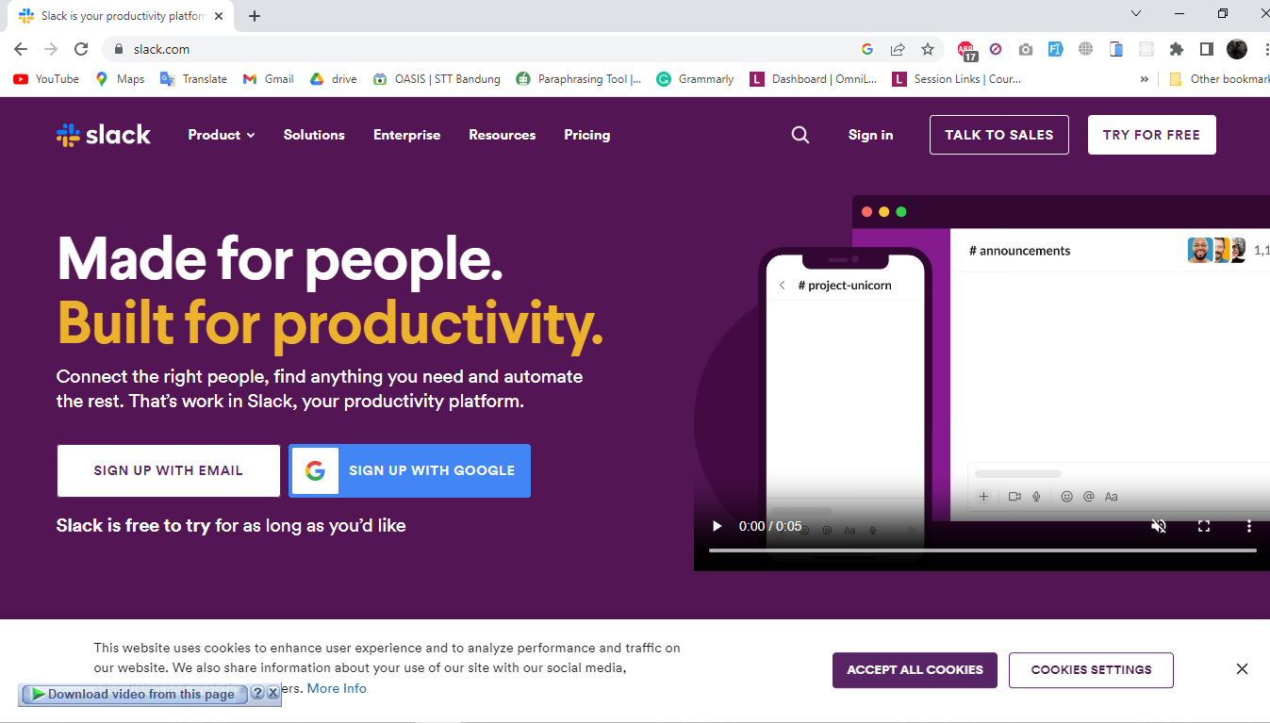
   2. **Create a workspace**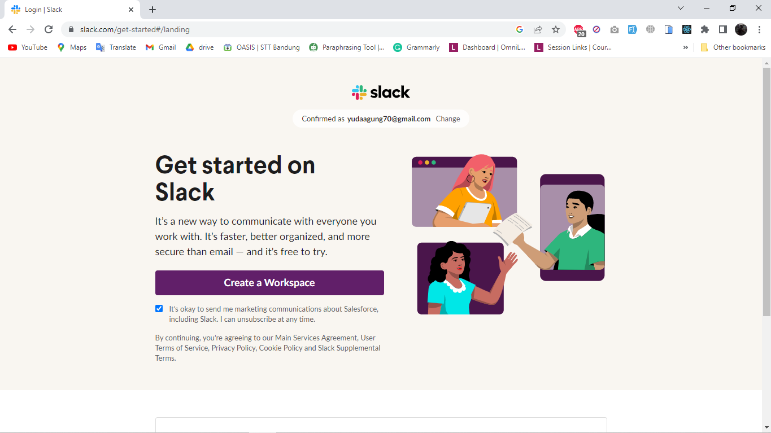
   3. **Name the workspace**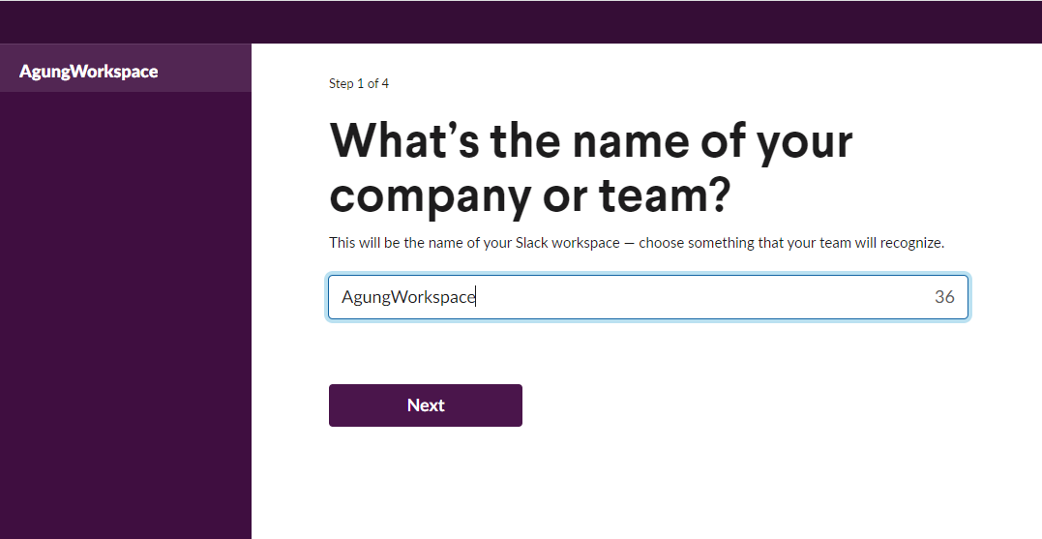
   4. **Setting your biodata**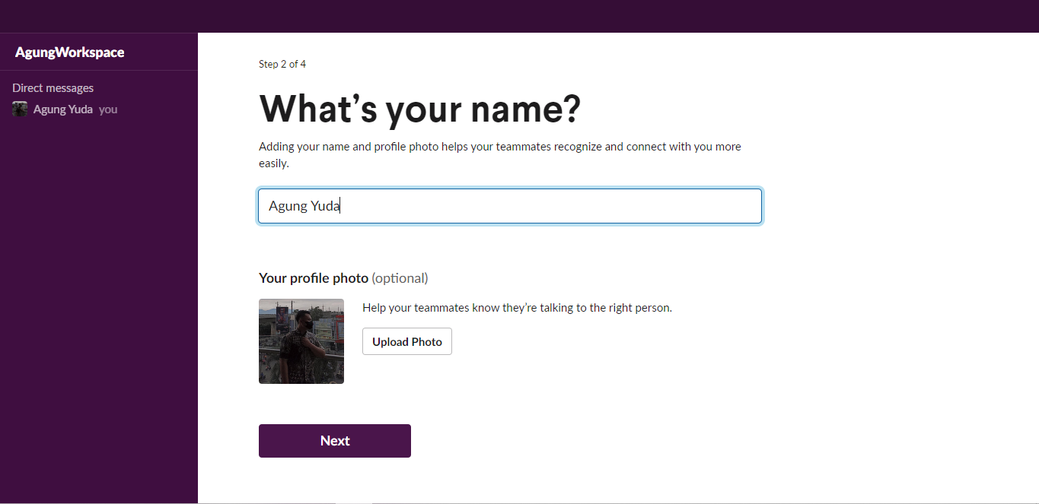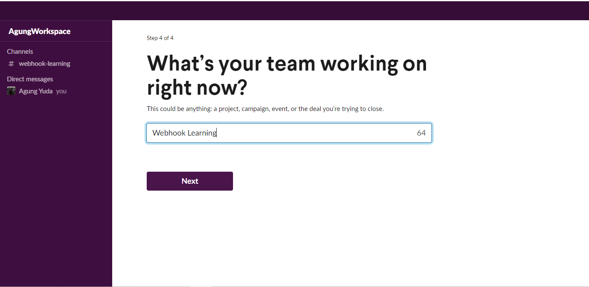
   5. **The Workspace is ready to use**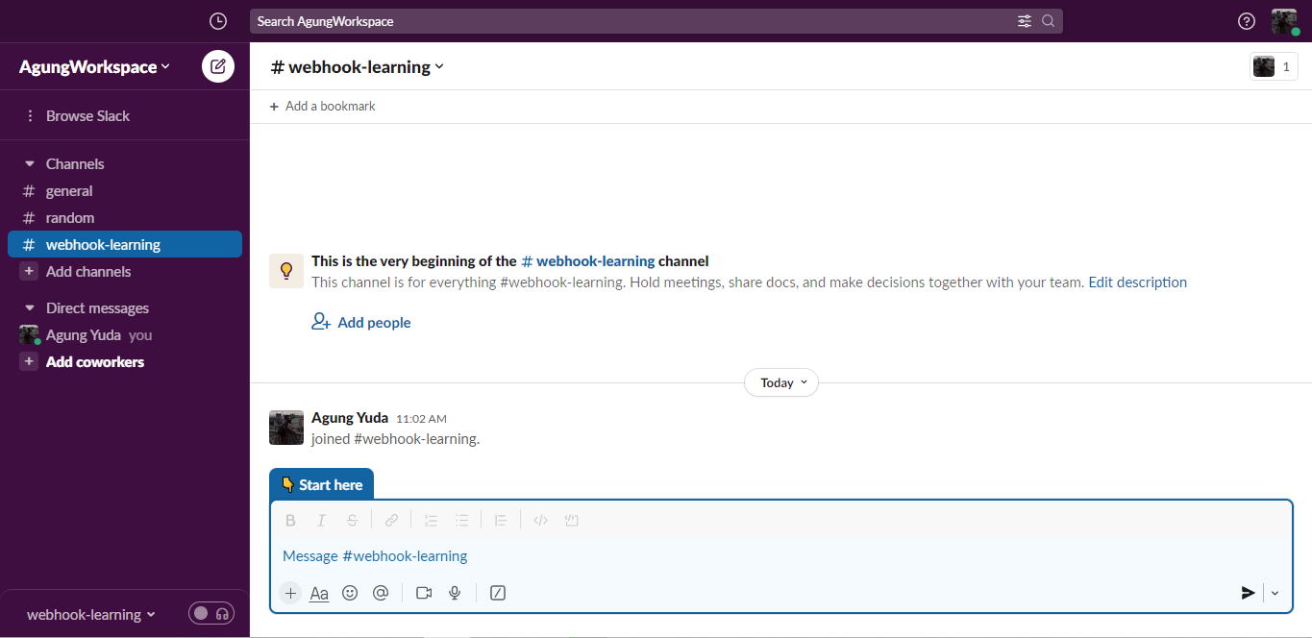
2. **Creating an App for webhook integration**
   1. **Open api.slack.com and select Your Apps (DO NOT CLOSE THE PREVIOUS TAB)**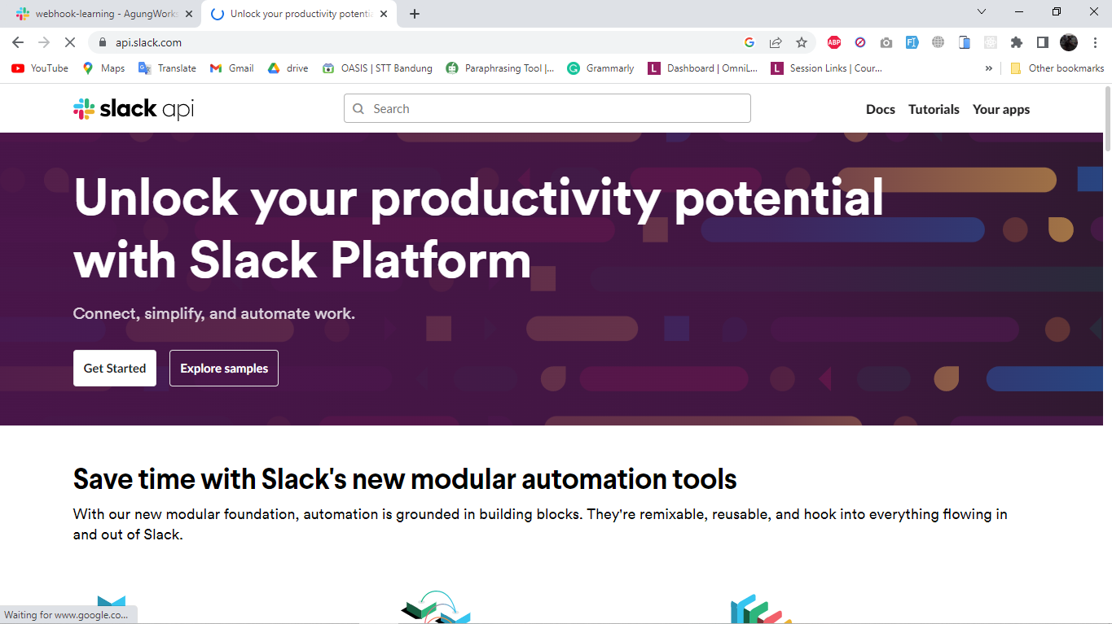
   2. **Create your app and select from scratch**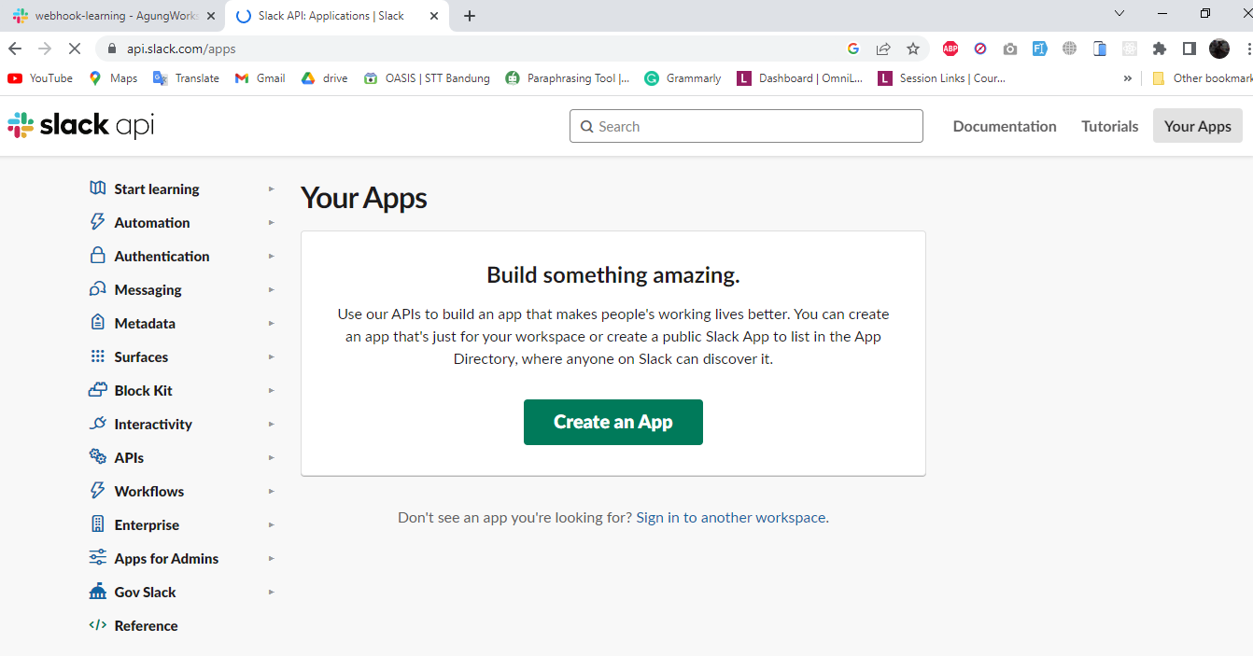
   3. **Name your app and choose the workspace**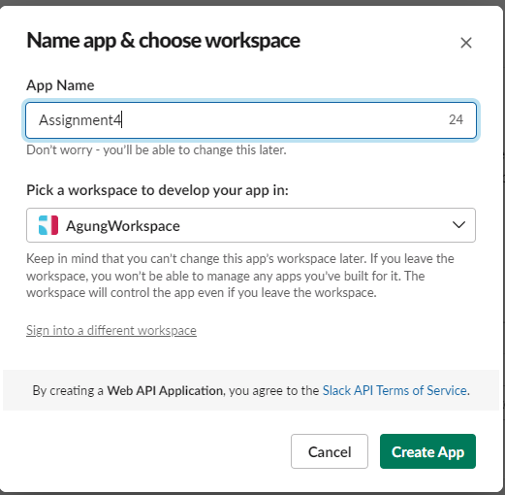
3. **Enabling Webhook in App**
   1. **After the app created, go to Incoming Webhook and activate the incoming webhook**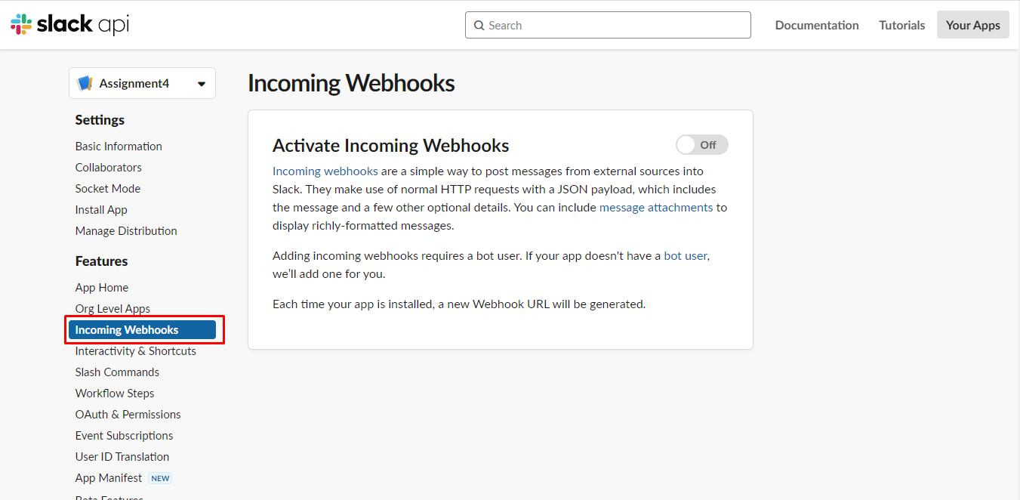
   2. **Scroll down and add New Webhook to Workspace**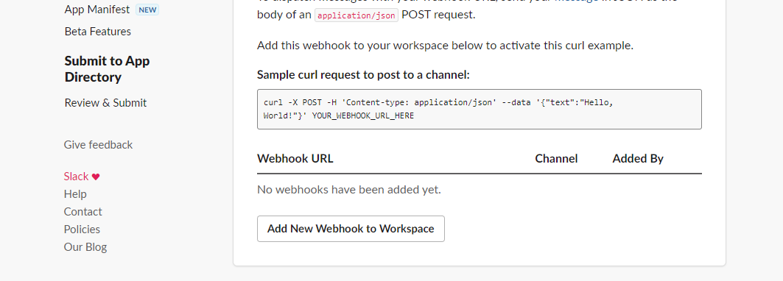
   3. **Choose your account and click Allow**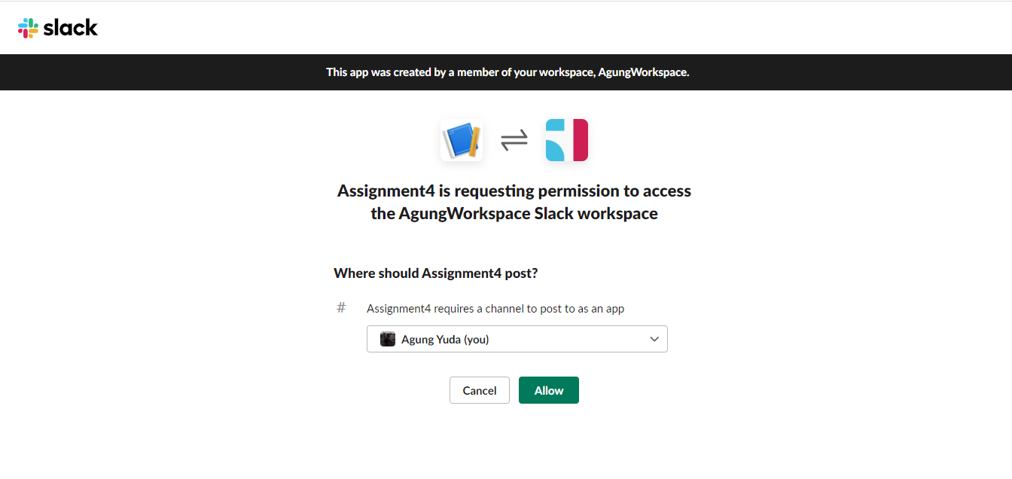
   4. **Now the webhook is ready to use**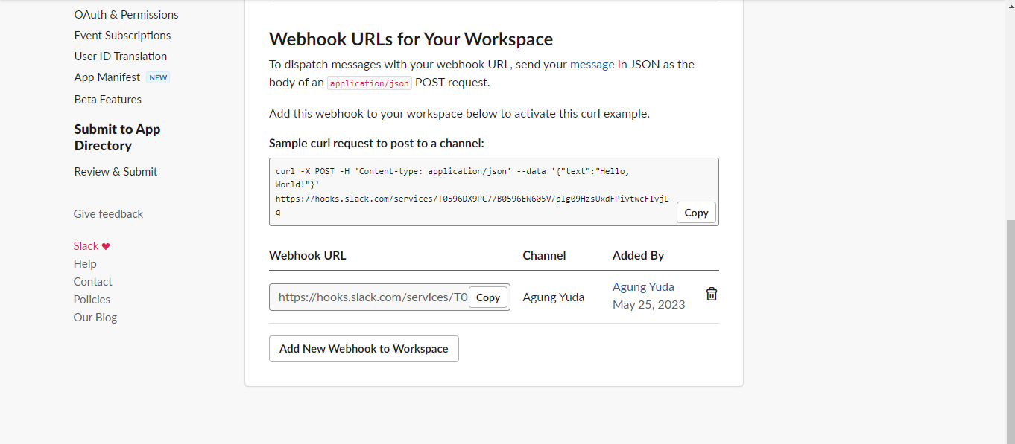
4. **Implement webhook Integration in XYZ portal which is already developed.**
   1. **MessageController.java**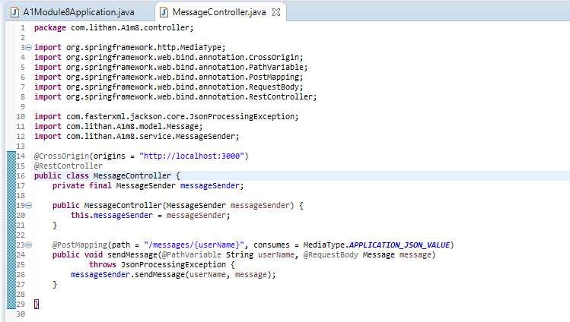
   2. **Message.java**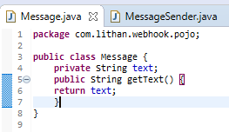
   3. **MessageSender.java**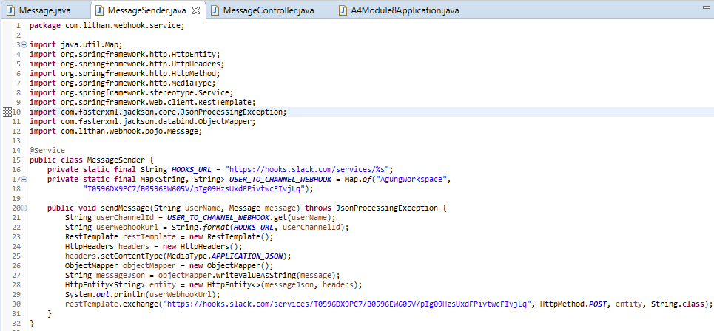
5. **Testing using Postman**
   1. **Open Postman software and add new request. Change method to POST and add the link**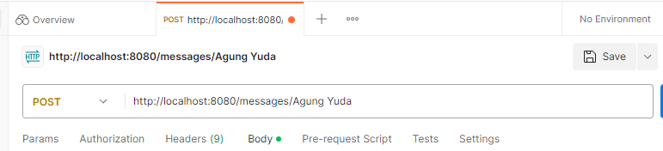
   2. **Go to Headers for key add to Content-Type and value application/json**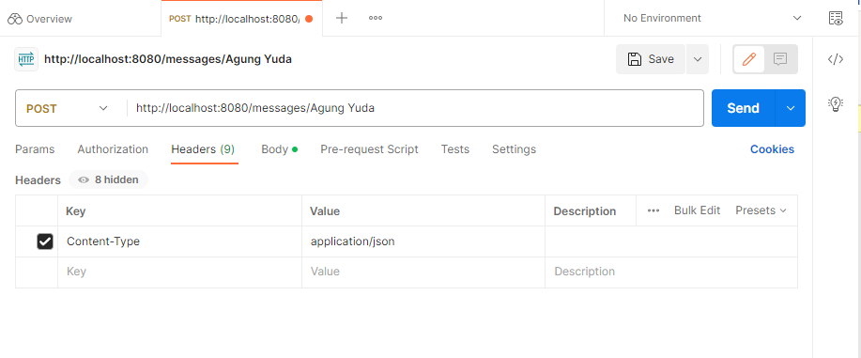
   3. **Go to body and click raw and change to JSON. Add the message that you want to send**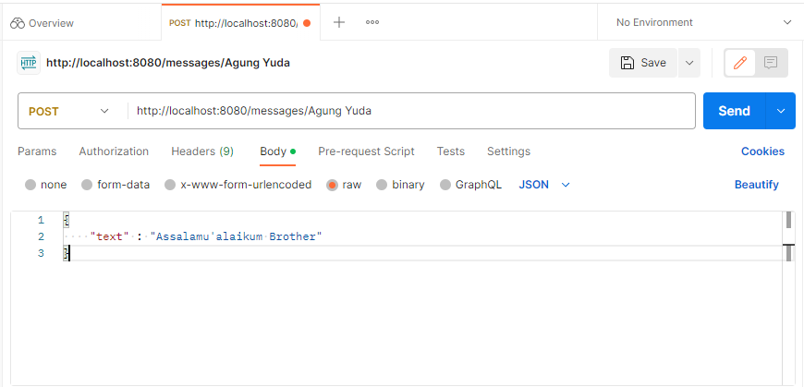
   4. **Here’s the Result**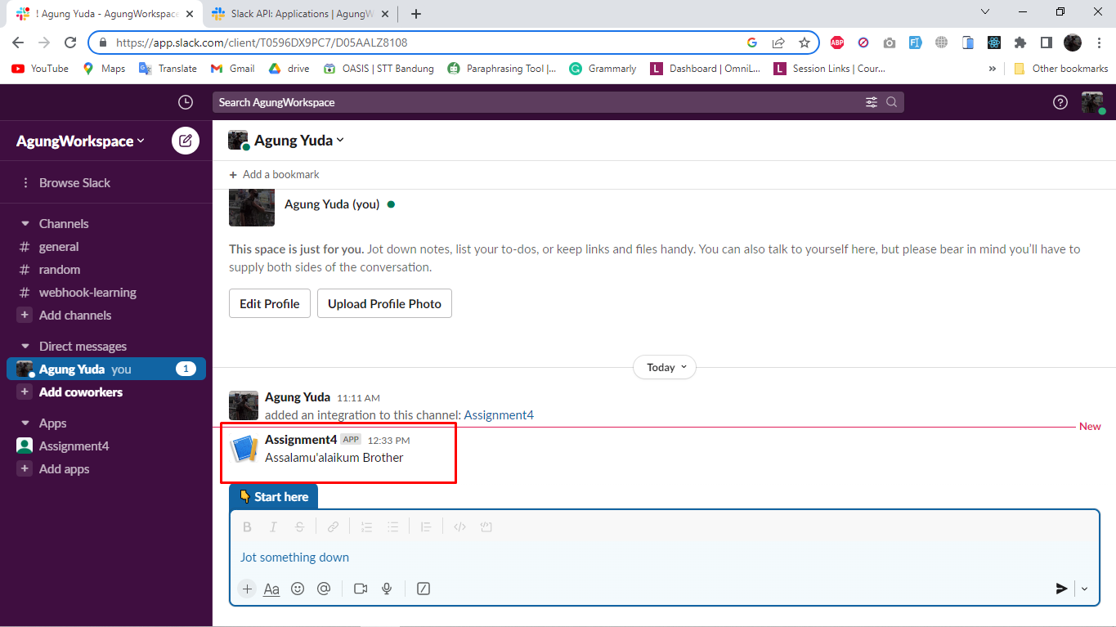
6. **Use the API in React Application.**
   1. **Make the service.js for running the method**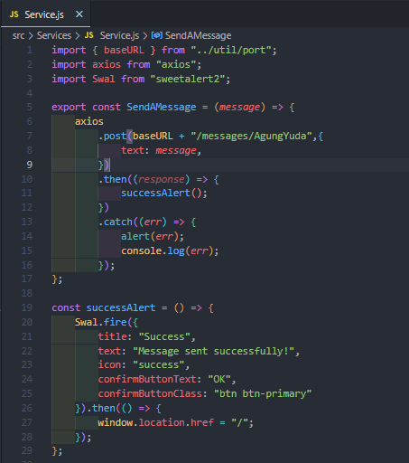
   2. **Create the page ContactUs.jsx**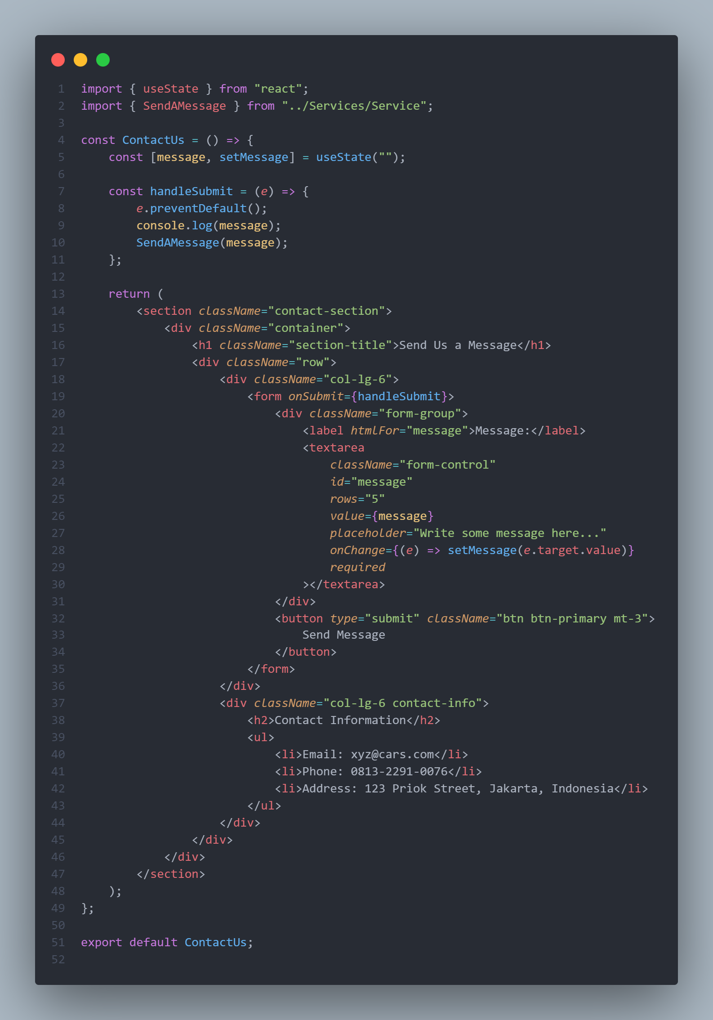
   3. **Don’t forget to add new route for Contact Us**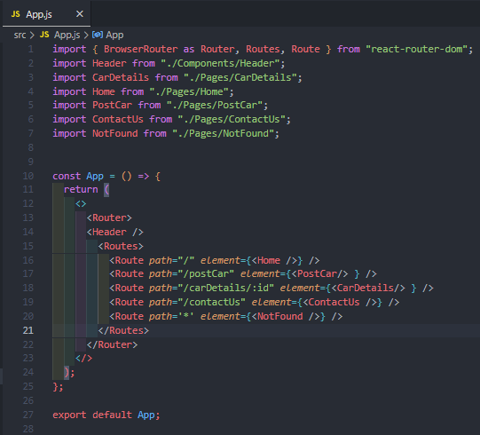
   4. **This is the Contact Us Page**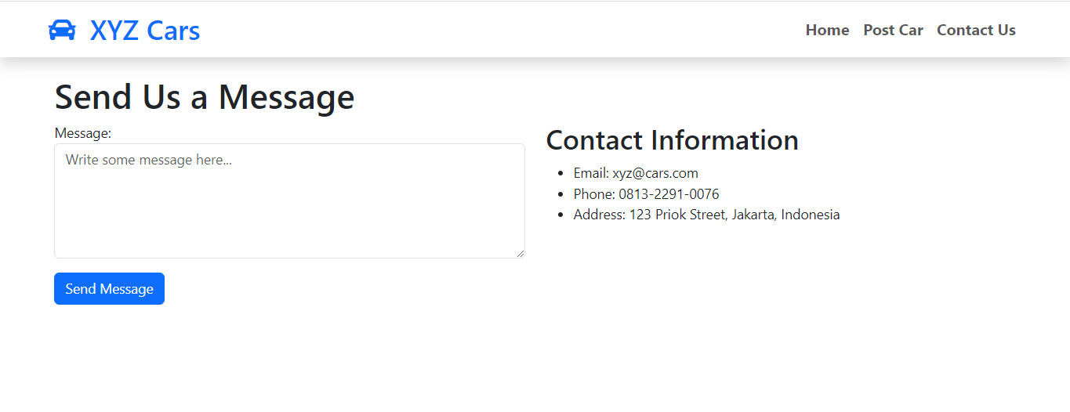
   5. **We add some message**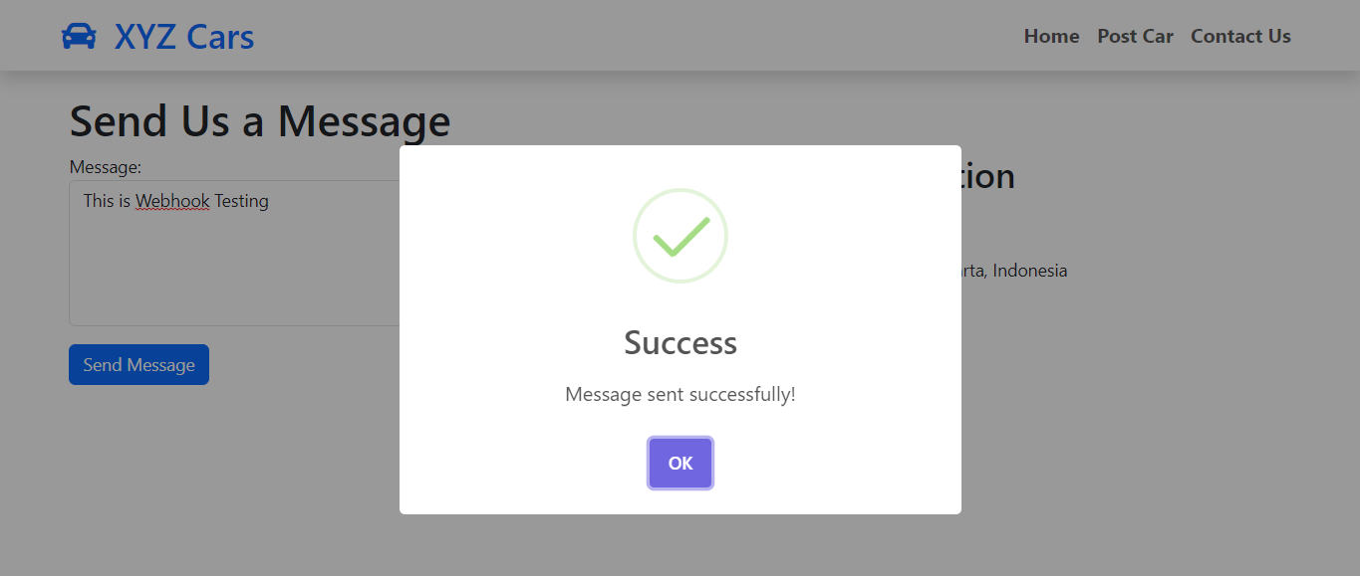
   6. **This is the message in slack**